*\*Dr. X’s total effort commitment is X% (X CM). For budgeting purposes under the new DMS activities, a total of Y% (Y CM) is budgeted under Senior/Key Personnel Costs – section A and the remaining Z% (Z CM) is budgeted below under Data Sharing and Management Cost – section F.*

*Personnel cost disclaimer for data management and sharing:  Per NIH guidelines asking applicants to budget associated personnel costs related to the preparation, management and/or sharing of data activities, a portion of the PD/PI’s (or other personnel) salary and associated fringes are shown here for tracking the time it takes personnel to undertake data management and sharing activities. The PD/PI’s (or other personnel) total commitment is x.xx calendar months as shown under the personnel justification section describing his/her role. The costs budgeted within the personnel section (A) (Effort related to research activity) in addition to the costs listed under the DMS section (F) (Effort associated with DMSP activities) make up the total dollar request needed to cover the full commitment for the PD/PI.  Please note that although a portion of the personnel costs are included here to account for overall DMS costs associated with the project, if awarded these salary/fringe dollars will be processed as personnel costs following the institution’s policy for treatment of salary on sponsored awards.*

**Detailed Budget – Example 1:**

PD/PI (John Smith) is the only one who will have effort associated with the DMSP. His total effort is 5 months with 0.5 months associated with the DMSP. Assuming he is at the 2023 cap of $212,100, we would expect the R&R budget to be completed as follows:

A. Senior/Key Person

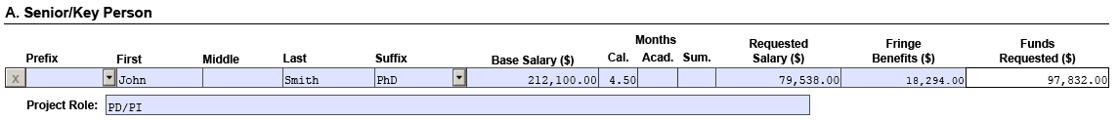

F. Other Direct Costs (Assuming no other costs are associated with the Data Management and Sharing Plan)

The Justification would state:

A. Senior/Key Person

**John Smith, PhD Principal Investigator 4.5 Calendar person-months**

Dr. Smith’s role and pertinent research activity information

*\*Dr. Smith’s total effort commitment is 41.67% (5 CM). For budgeting purposes under the new DMS activities, a total of 37.5% (4.5 CM) is budgeted under Senior/Key Personnel Costs – section A and the remaining 4.17% (0.5 CM) is budgeted below under Data Sharing and Management Cost – section F.*

F8. Data Management and Sharing Costs

*Personnel cost disclaimer for data management and sharing:  Per NIH guidelines asking applicants to budget associated personnel costs related to the preparation, management and/or sharing of data activities, a portion of the PD/PI’s salary and associated fringes are shown here for tracking the time it takes personnel to undertake data management and sharing activities. The PD/PI’s total commitment is 5.00 calendar months as shown under the personnel justification section describing his role. The costs budgeted within the personnel section (A) (4.5 calendar months) in addition to the costs listed under the DMS section (F) (0.5 calendar months) make up the total dollar request needed to cover the full commitment for the PD/PI.  Please note that although a portion of the personnel costs are included here to account for overall DMS costs associated with the project, if awarded these salary/fringe dollars will be processed as personnel costs following the institution’s policy for treatment of salary on sponsored awards.*

**Detailed Budget – Example 2:**

Two or more people on the grant will have effort associated with the DMSP. Dr. John Smith (at the salary cap of $212,100) will be committing a total of 5 calendar months with 0.5 calendar moths associated with the DMSP, and Dr. Jane Smith (base salary of $195,000) will be committing a total of 3 calendar months with 0.25 months associated with the DMSP.

A. Senior/Key Person

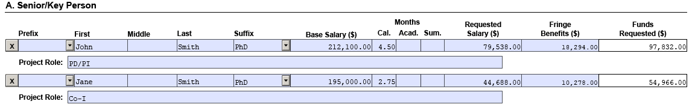

F. Other Direct Costs (Assuming no other costs are associated with the Data Management and Sharing Plan)



The Justification would state:

A. Senior/Key Person

**John Smith, PhD Principal Investigator 4.5 Calendar person-months**

Dr. John Smith’s role and pertinent research activity information

*\*Dr. John Smith’s total effort commitment is 41.67% (5 CM). For budgeting purposes under the new DMS activities, a total of 37.5% (4.5 CM) is budgeted under Senior/Key Personnel Costs – section A and the remaining 4.17% (0.5 CM) is budgeted below under Data Sharing and Management Cost – section F.*

**Jane Smith, PhD Co-Investigator 2.75 Calendar person-months**

Dr. Jane Smith’s role and pertinent research activity information

*\*Dr. Jane Smith’s total effort commitment is 25% (3 CM). For budgeting purposes under the new DMS activities, a total of 22.9167% (2.75 CM) is budgeted under Senior/Key Personnel Costs – section A and the remaining 2.0833% (0.25 CM) is budgeted below under Data Sharing and Management Cost – section F.*

F8. Data Management and Sharing Costs

*Personnel cost disclaimer for data management and sharing:  Per NIH guidelines asking applicants to budget associated personnel costs related to the preparation, management and/or sharing of data activities, a portion of Dr. John Smith’s and Dr. Jane Smith’s salaries and associated fringes are shown here for tracking the time it takes personnel to undertake data management and sharing activities. Dr. John Smith’s total commitment is 5.00 calendar months and Dr. Jane Smith’s total commitment is 3.00 calendar months as shown under the personnel justification section describing their roles. The costs budgeted within the personnel section (A) (4.5 calendar months for Dr. John Smith and 2.75 calendar months for Dr. Jane Smith) in addition to the costs listed under the DMS section (F) (0.5 calendar months for Dr. John Smith and 0.25 calendar months for Dr. Jane Smith) make up the total dollar request needed to cover the full commitment for the PD/PI and Co-I.  Please note that although a portion of the personnel costs are included here to account for overall DMS costs associated with the project, if awarded these salary/fringe dollars will be processed as personnel costs following the institution’s policy for treatment of salary on sponsored awards.*

**Modular Budget Example *(This example assumes no increase above the salary cap in outer years)*:**

**Personnel Justification:**

**John Smith, PhD (Principal Investigator)**

Dr. Smith’s role and pertinent research activity information. Dr. Smith will devote 4.5 calendar months (37.5% effort)* in all years.

*\*Dr. Smith’s total effort commitment is 41.67% (5 months) each year. For budgeting purposes under the new DMS activities, a total of 37.5% (4.5 months) is budgeted under Senior/Key Personnel Costs – Section A and the remaining 4.17% (0.5 months) is budgeted under Data Management and Sharing Costs – Section F.*

*Personnel cost disclaimer for data management and sharing: Per NIH guidelines asking applicants to budget associated personnel costs related to the preparation, management and/or sharing of data activities, a portion of the PD/PI’s (or other personnel) salary and associated fringes are shown here for tracking the time it takes personnel to undertake data management and sharing activities. The PD/PI’s (or other personnel) total commitment is 5 months. The costs budgeted within the personnel section (A) (4.5 months) in addition to the costs listed under the DMS section (F) (0.5 months) make up the total dollar request needed to cover the full commitment for the PD/PI. Please note that although a portion of the personnel costs are included here to account for overall DMS costs associated with the project, if awarded these salary/fringe dollars will be processed as personnel costs following the institution’s policy for treatment of salary on sponsored awards.*

**Additional Narrative Justification:**

Data Sharing and Management Costs $54,350

Dr. John Smith (Principal Investigator). Dr. Smith will perform the below list of duties related to Data Management and Sharing Costs. Duties X, Y, and Z. Dr. Smith will dedicate 0.5 months (4.17% effort) to data sharing and management efforts on this project per year. Costs per year include effort ($8,837) and fringe benefits ($2,033).

*Personnel cost disclaimer for data management and sharing: Per NIH guidelines asking applicants to budget associated personnel costs related to the preparation, management and/or sharing of data activities, a portion of the PD/PI’s salary and associated fringes are shown here for tracking the time it takes personnel to undertake data management and sharing activities. The PD/PI’s total commitment is 5.0 months. The costs budgeted within the personnel section (A) (4.5 calendar months) in addition to the costs listed under the DMS section (F) (0.5 months) make up the total dollar request needed to cover the full commitment for the PD/PI. Please note that although a portion of the personnel costs are included here to account for overall DMS costs associated with the project, if awarded these salary/fringe dollars will be processed as personnel costs following the institution’s policy for treatment of salary on sponsored awards.*